The Form 990-N electronic-filing system moved from Urban Institute’s website to IRS.gov in February. All filers must register at IRS.gov prior to filling their next Form 990-N. This is a one-time registration; you won’t be asked to register again when filing next year. See below for step-by-step instructions.
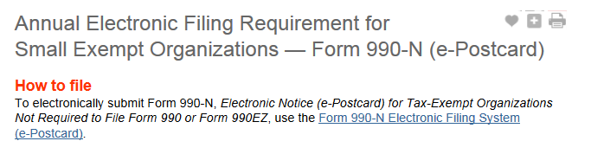
Go to irs.gov/990N.
Click on Form 990-N Electronic Filing System (e-Postcard)

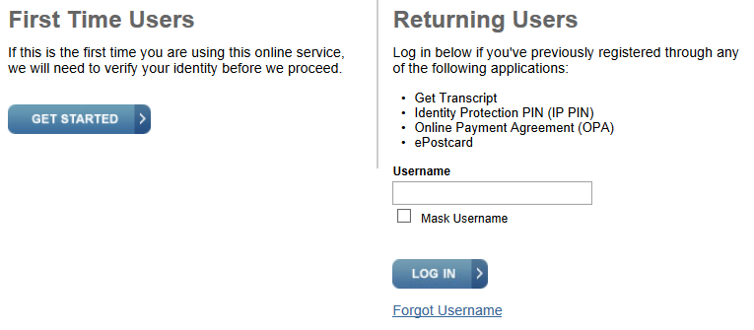
Click “GET STARTED”

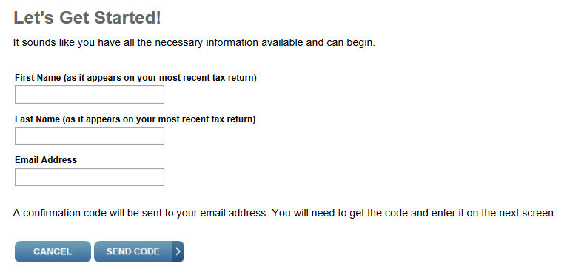
Enter name and email address - click “SEND CODE”

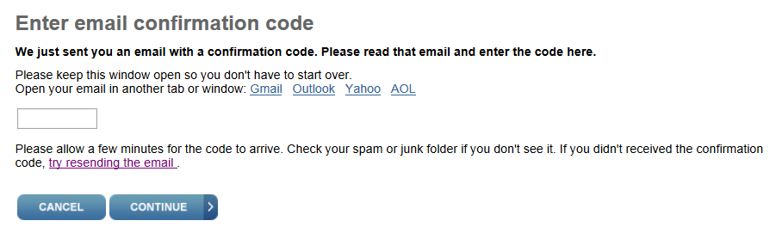
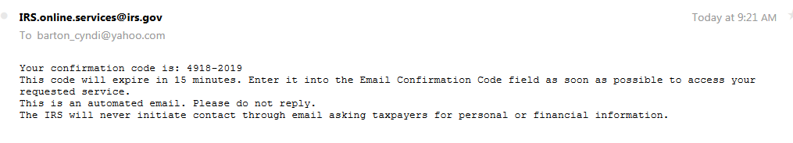
You will receive an email with a confirmation code. Note: check your spam/junk folder if you don’t receive this email. Enter the code received and click “CONTINUE.”

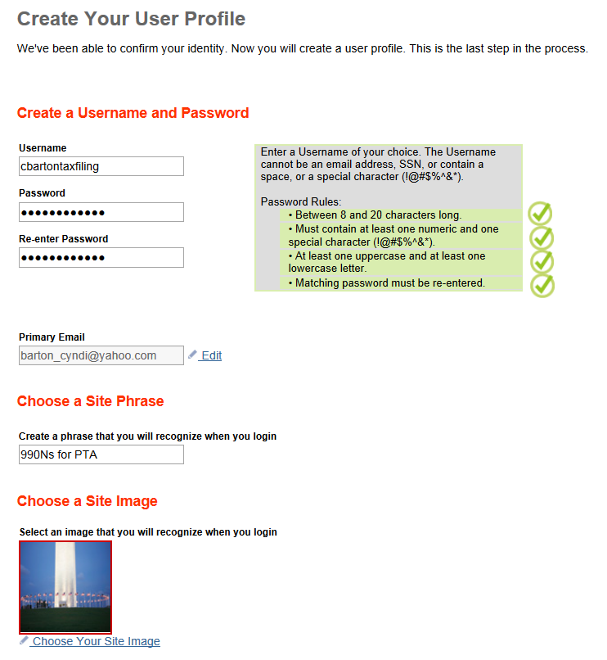
CREATE YOUR USER PROFILE

Choose a username and password.

Choose a site phrase and site Image. These will appear on your login page before you enter your password. Seeing these while logging in ensures that you are on the official IRS website and not a fake/scam site Create your user profile.

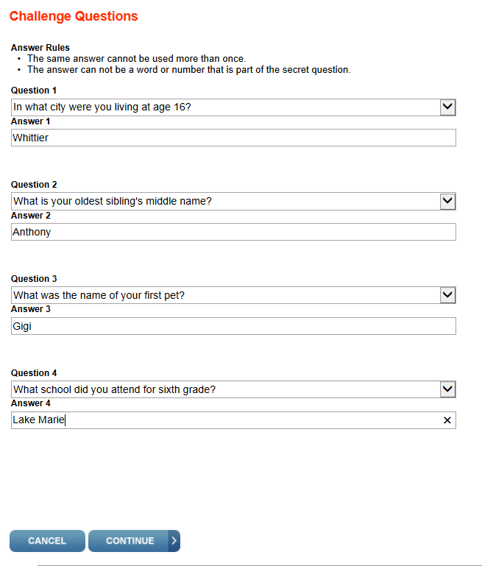

Choose four (4) challenge questions. When complete click “CONTINUE”

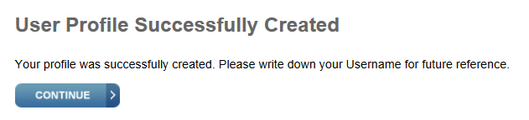
The “User Profile Successfully Created” page will appear. Click “CONTINUE.”

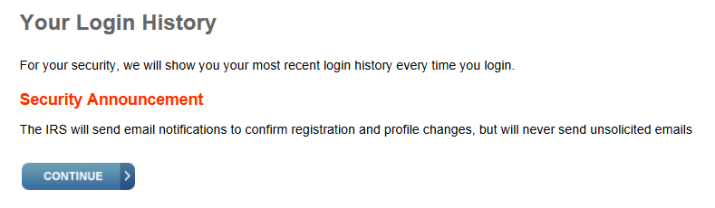
Click “CONTINUE” on the Login History page

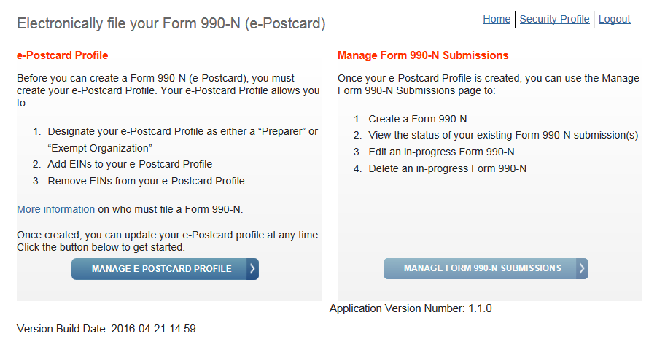
Click on “MANAGE E-POSTCARD PROFILE”

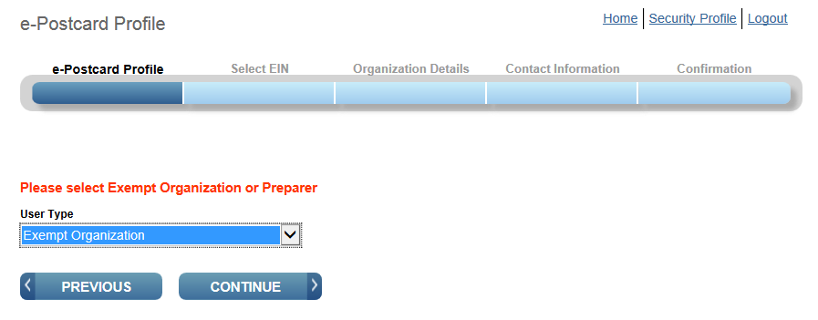
Select Exempt Organization as the User Type. Click “CONTINUE.”

Enter the EIN of your PTA and click on “CREATE NEW FILING.”
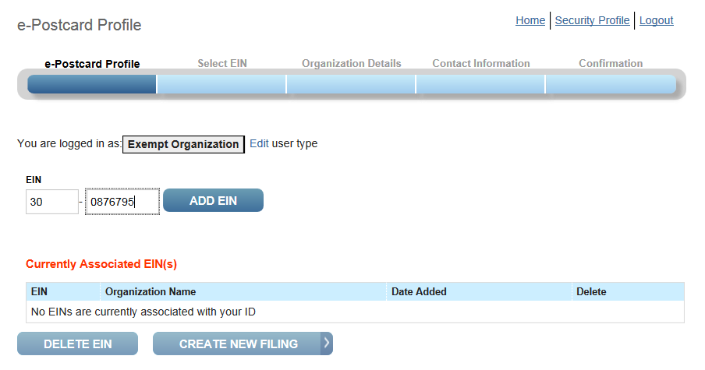

The EIN number will be add to the “Currently Associated EIN(s)” list. Note: Confirm that you are using the correct EIN for your PTA and that you have entered that number correctly.
Click “CREATE NEW FILING.”
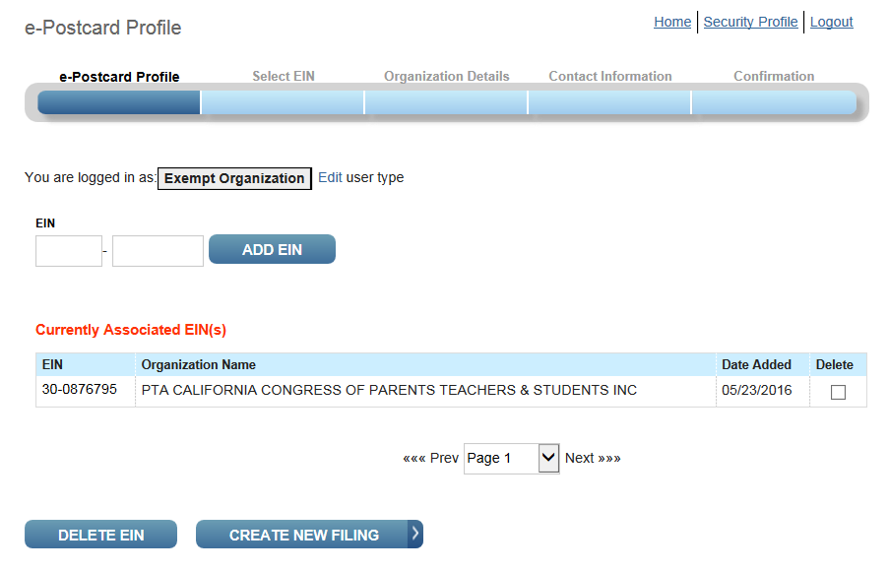

FILING THE 990-N e-POSTCARD

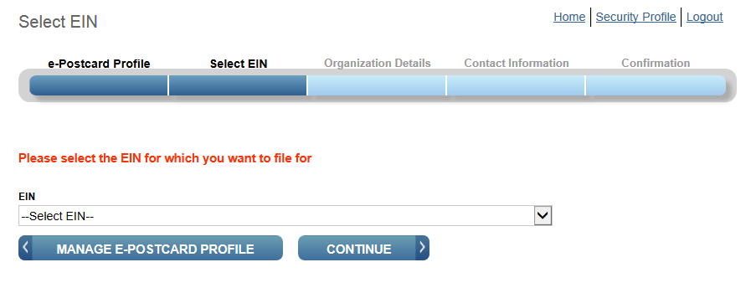
Select the EIN from the list. Click “CONTINUE.”

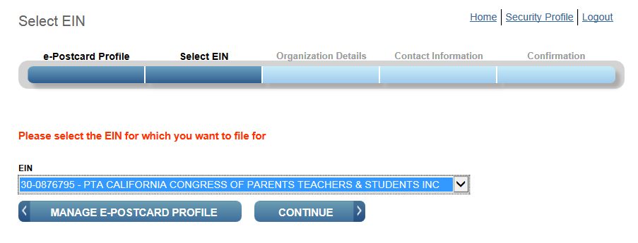
Click “CONTINUE.”

ORGANIZATION DETAILS Screen
The tax year ending date is prefilled and you cannot change it. IF this is different than what is stated in your bylaws, please contact your district PTA or California State PTA at taxinfo@capta.org.
Has your organization terminated or gone out of business? Select NO.
Are your gross receipts normally $50,000 or less? Select YES.
(If your gross income is more than $50,000 you will need to file the 990EZ or 990.)
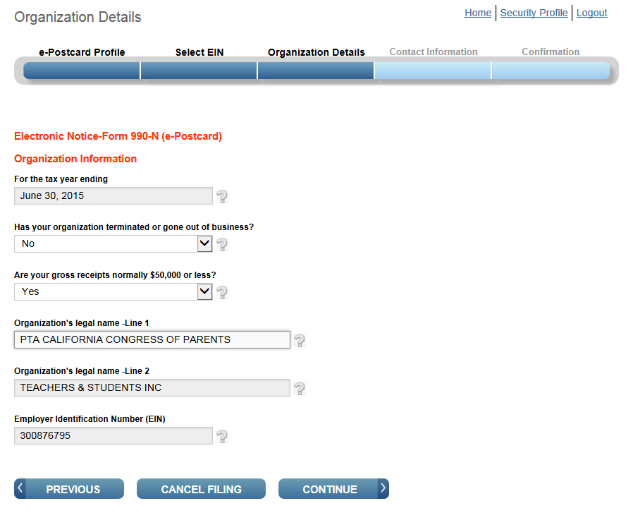
The other fields are prefilled. Click “CONTINUE.”

CONTACT INFORMATION Screen
DBA – Enter the name of your PTA as it appears in your bylaws.
Address – Enter the school address.
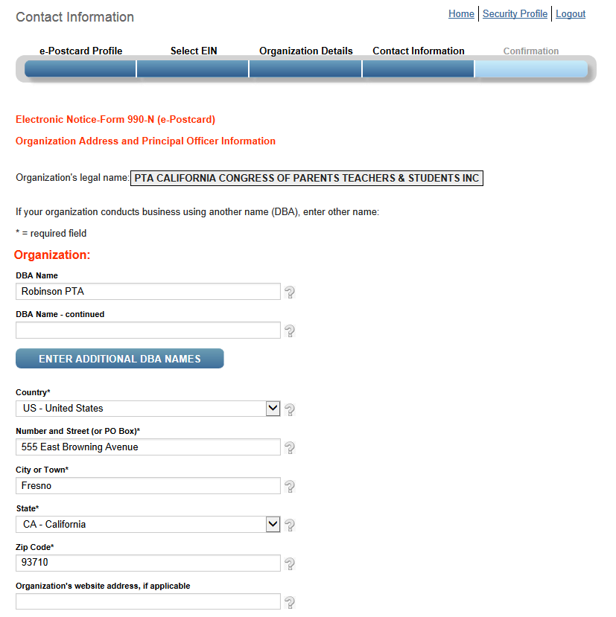

CONTACT INFORMATION Screen (continued)
Principal Officer – Enter the president’s name.
Address – Enter the school address. It is not necessary to enter the president’s home address.
(Note: For purposes of this example the California State PTA office has been entered.)
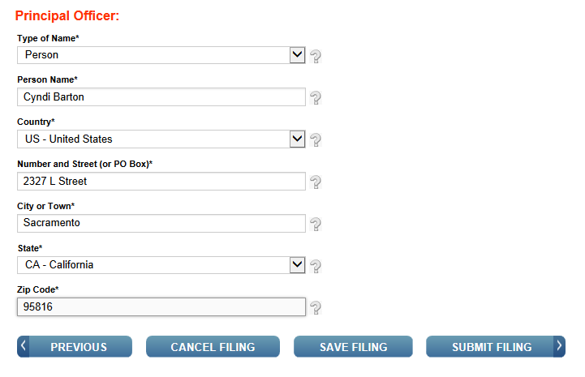
Click “SUBMIT FILING.”

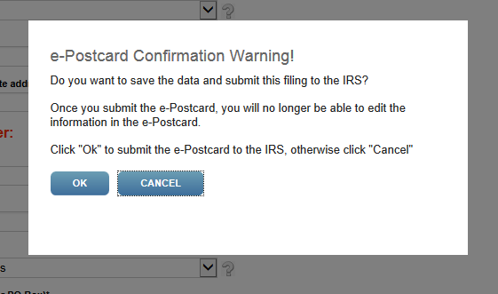
Click OK. Your 990-N filing is complete and editing is no longer possible.

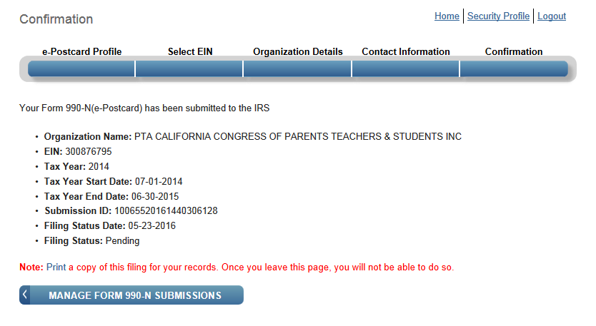
Please save (PDF, JPEG, etc.) or print this confirmation page. This is your only opportunity to do this. Click “MANAGE FORM 990-N SUBMISSIONS.”

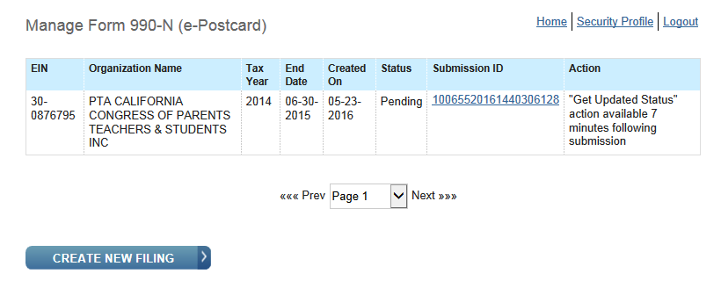
Your submission will show the status of PENDING. Refresh the page after 7 minutes (F5) and the “GET UPDATED STATUS” should now be visable. Click to see if filing was accepted.

If the status shows as “ACCEPTED,” you have met the filing requirement. You may want to print a copy of this page and attach it to the previous confirmation you saved or printed.
IF THE STATUS SHOWS AS REJECTED, please contact your district PTA or California State PTA at taxinfo@capta.org.
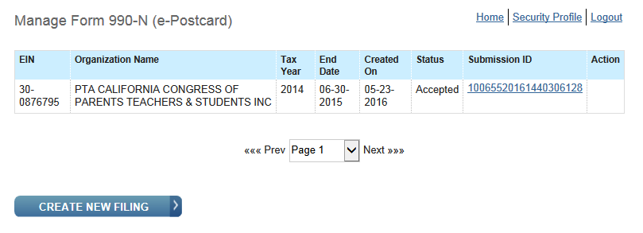

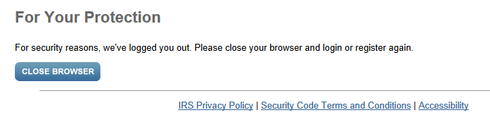
Close your browser.
You are DONE!

