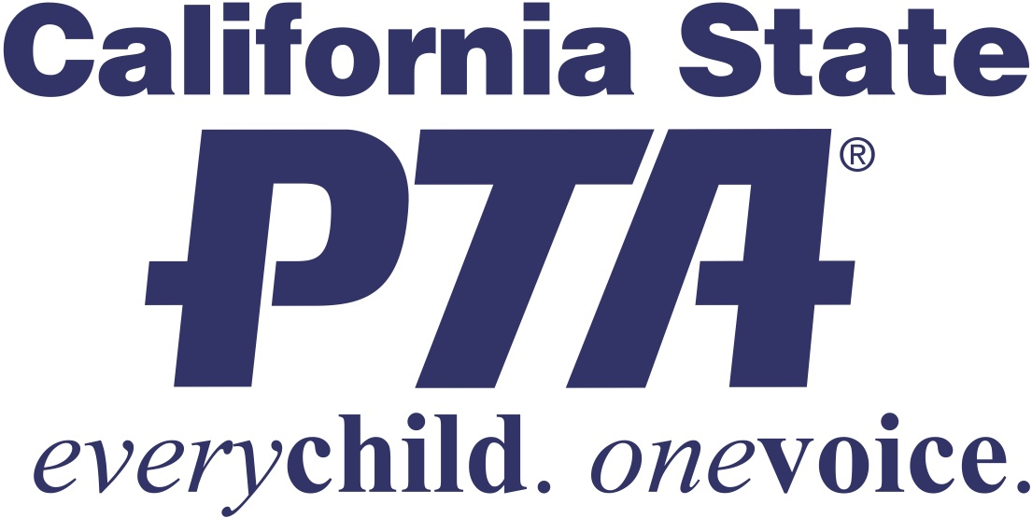

SCHOOL NAME
is better...with YOU!
With your PTA membership, all things are possible!
YOUR PTA EVENTS AND PROGRAMS  - Click here to enter text.  - Click here to enter text.  - Click here to enter text. | “We invite every parent, teacher and neighbor to join with PTA, as we work to make SCHOOL NAME the best it can be for our students...our most precious resource.”  PRINCIPAL NAME PTA PRESIDENT NAME  PRINCIPAL PHONE PRINCIPAL EMAIL PRESIDENT PHONE PRESIDENT EMAIL
PTA also means exclusive extra perks for YOU!
Baskin Robbins – Aquarium of the Pacific – LEGOLAND
Smart & Final – SWANK Movie Licensing USA
LOCAL DISCOUNT 1 ~ LOCAL DISCOUNT 2
Learn more online at www.capta.org
School Name PTA –
Support your child
and your school –
Support PTA!

With your PTA membership:
- You show your children that school matters, and that you are invested in their success.

- You demonstrate to your child that success in school is the pathway to college, a career and a productive life!

- You partner with the principal, teachers and staff to make your child's school safe, welcoming, a hub of learning, and a fun place to be.

- You share in campus events and experiences that make your child’s school days more memorable!

- You connect with other parents, and become part California State PTA and National PTA, the largest and most powerful children’s advocacy organization in the country.

- You help make sure parents and family members voices are heard when important decisions that affect your school are made.

Here’s how to join PTA:
STEP 1
- STEP 2
- STEP 3

Include any additional information as needed.

For more information:
Visit WEBSITE ADDRESS

SCHOOL NAME PTA
STREET ADDRESS, CITY, CA ZIP CODE – WEBSITE ADDRESS

